**Data Collection:**

We have combined 3 datasets: Kaggle, ciplab, celeb-df

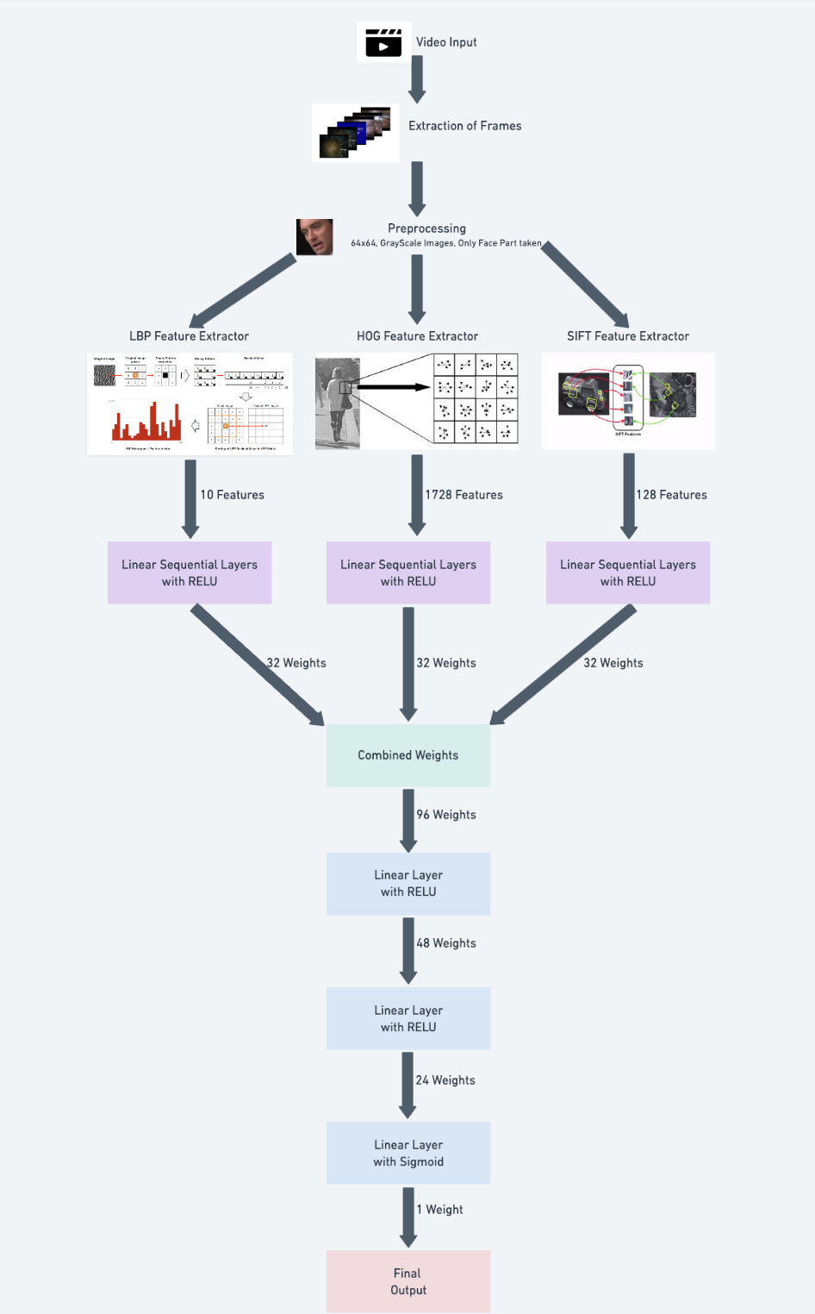

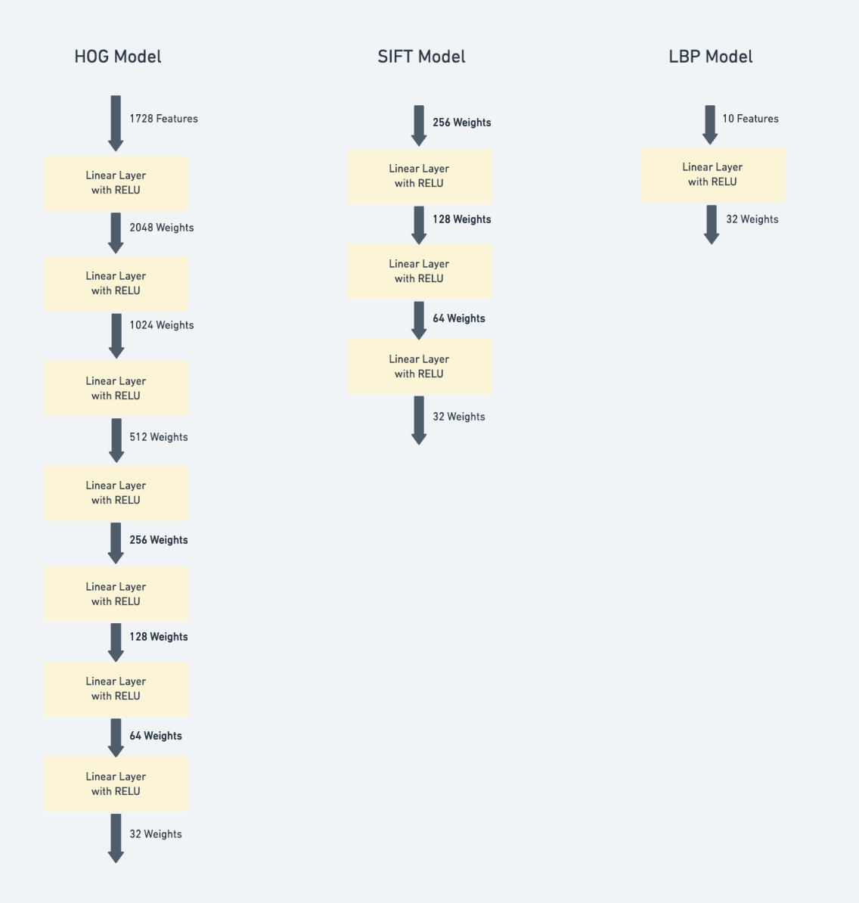

**Step 1: Data Preprocessing:**

We have extracted the frames from videos and cropped the face part

Images are made 64x64 and gray.

**Step 2: feature extraction:**

Cropped images are passed to feature extractors LBP,SIFT and HOG.

Each of them give different dimensions data.

**Step 3: passing features on linear sequential layers:**

Different feature extractor feature is passed on different layers as shown above(refer code for clarity) till we get 32 features

**Step 4: combining all 32 weights:**

We get 96 weights here, we again pass it on linear layers till we get 1 output

**Step 5: checking the final output:**

>=0.5 deepfake or else real, compare with actual layer and do backpropagation

Adam optimizer and BCE loss

There’s batch normalization and relu in each linear layer